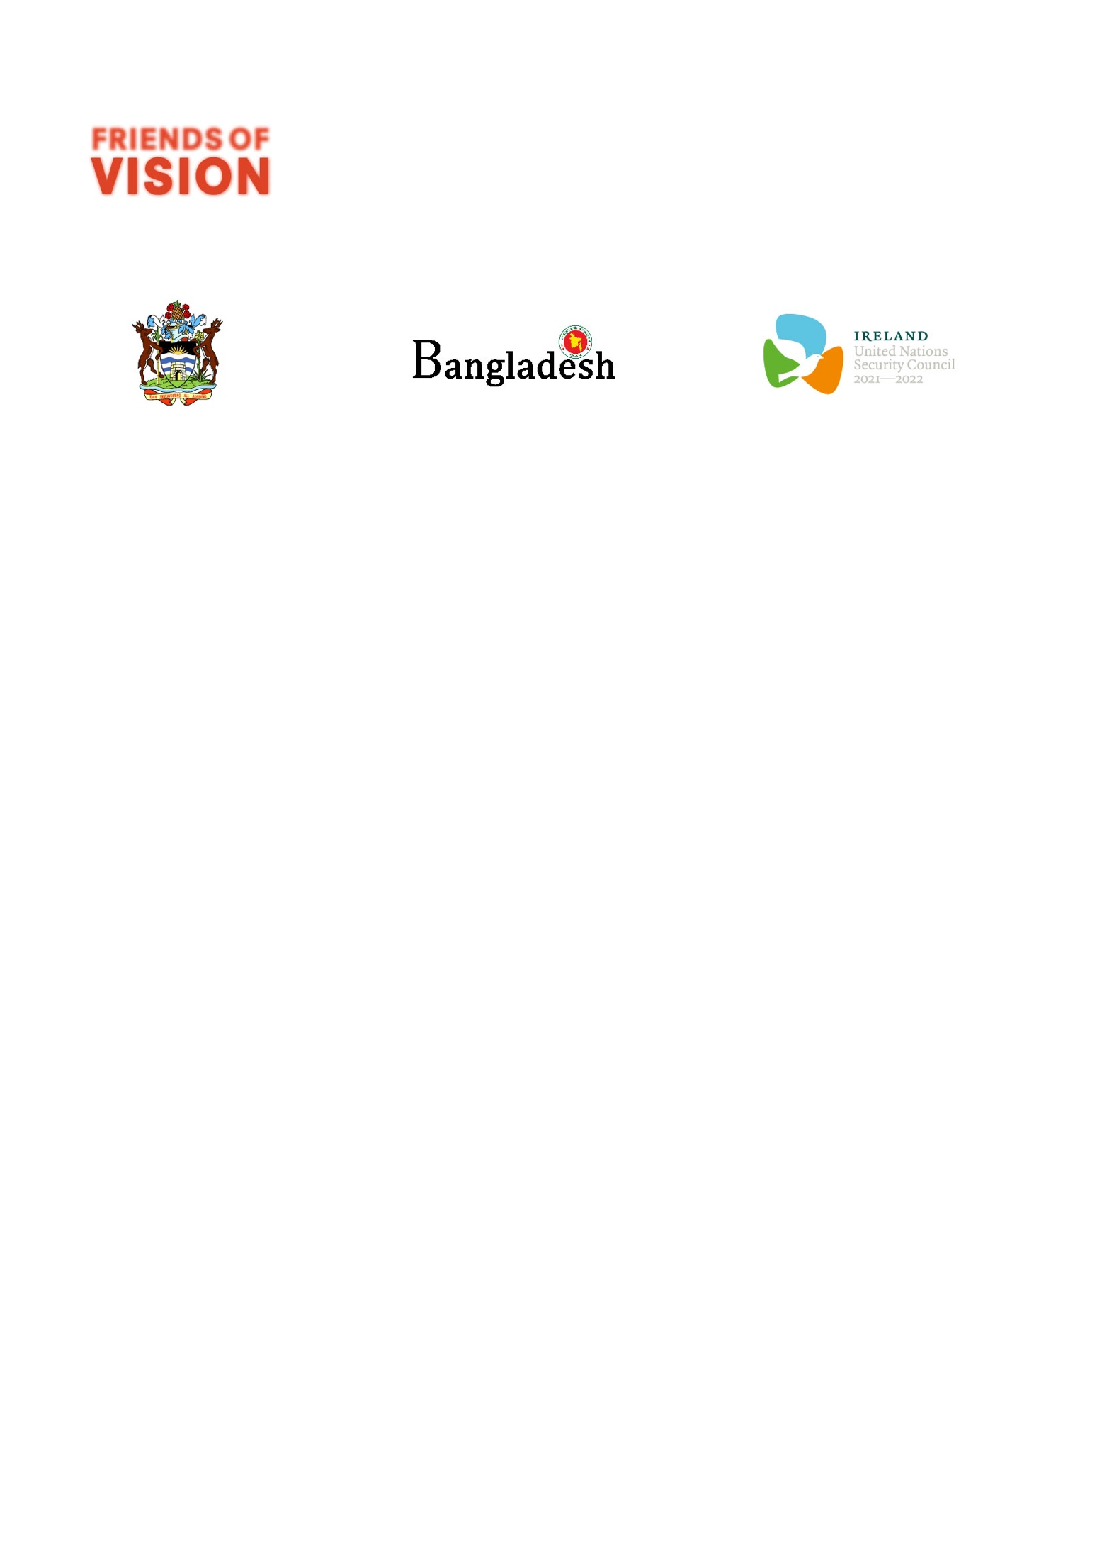

**UN Special Envoy on Vision**

**Social Media Messaging**

As we collectively call on UN Secretary-General António Guterres to appoint a UN Special Envoy on Vision, we want to help audiences understand the significance of this ask; that the appointment will build on the significant momentum developed around eye health over the past three years and enable a global advocate to lead the implementation of the UN General Assembly Resolution on ‘Vision for Everyone’.

IAPB has produced several social media message and assets that we invite you to use to help amplify this important call to action. These can all be found here.

**SAMPLE POST #1**

|  |  |  |
| --- | --- | --- |
| PLATFORM | POST COPY | ARTWORK |
| LinkedIn | #NEWS: Over 60 countries and more than 150 eye health organisations are calling on the @United-Nations to appoint a Special Envoy on Vision.    A Special Envoy on Vision will serve as a global champion for vision and mobilise national action on eye health, ensuring that the necessary resources and technical assistance are provided, particularly in low-and middle-income countries.  We are proud to be part of this call.  *Relevant tags:*  #2030Insight #SDGs #UNFOV  @world-health-organization @international-agency-for-the-prevention-of-blindness @cbm-international @sightsavers @Visionspring @onesight-essilorluxottica-foundation @himalayan-cataract-project @RestoringVision  @the-vision-council @Fred-Hollows-Foundation @Seva-Foundation @antonioguterres @caroline-casey @peter-holland @Ian-Wishart @Kristan-Gross @Caroline-Harper @Ella-Gudwin @louisa-Syrett @anurag-hans @babar-qureshi @Kate-Moynihan @Marion-Lieser @ashley-mills @Peter-Hendicott @Derek-Hodkey @peter-schiessl @k-t-overbey @Rainer-Brockhaus @Martine-Abel-Williamson @Marc-Workman @madeleine-reiss @jamesyjchen @Christopher-Junge @kristenhoultonshaw @jennifergersbeck @amanda-davis @brandon-ah-tong @fiona-lawless @Reade-Fahs  @Iris-Van-den-Brand @Vasant-Narasimhan | Activism Video |
| Facebook | 🚨#NEWS: Over 60 countries and more than 150 eye health organisations are calling on the @UnitedNations to appoint a UN Special Envoy on Vision to ensure there is a global champion to help bring available, accessible and affordable eye health to all.  The Secretary General’s Special Envoy on Vision would serve as a global champion for vision and mobilise national action on eye health, ensuring that the necessary resources and technical assistance are provided, particularly in low-and middle-income countries.  We are proud to be part of this call.  *Relevant tags:*  #2030InSight #SDGs #UNFOV  @WHO @IAPB1 @cbm.international @fredhollows @sightsavers @visionspring @onesight @thevisioncouncil @RestoringVision @cureblindness @globalgoalsUN |
| Twitter | #NEWS: Over 60 countries and more than 150 eye health organisations are calling on the @UN to appoint a Special Envoy on Vision to help bring available, accessible and affordable eye health to all.  *Relevant tags:*  #2030InSight #SDGs #UNFOV  @IAPB1 @WHO @UN @cbmworldwide @fredhollows @Sightsavers @visionspring @opticalindustry @cureblindness @RestoringVision @onesightorg @antonioguterres |
| Instagram | 🚨#NEWS: Over 60 countries and more than 150 eye health organisations are calling on the @UnitedNations to appoint a UN Special Envoy on Vision to ensure there is a global champion to help bring available, accessible and affordable eye health to all.  The Secretary General’s Special Envoy on Vision would serve as a global champion for vision and mobilise national action on eye health, ensuring that the necessary resources and technical assistance are provided, particularly in low-and middle-income countries.  We are proud to be part of this call.  For more information on the UN Special Envoy on Vision follow @IAPB.  *Relevant tags:*  #2030InSight #SDGs #UNFOV @unitednations @who @antonioguterres @carolinecaseyhere @unpga @iapb @fredhollows @sightsavers @visionspringinc @onesight @cureblindness @thevisioncouncil @RestoringVision @sdgaction @theglobalgoals |

**SAMPLE POST #2**

|  |  |  |
| --- | --- | --- |
| PLATFORM | POST COPY | ARTWORK |
| LinkedIn | A UN Special Envoy on Vision means further embedding eye health in the #SustainableDevelopmentGoals, because;  ‣ When eye health is available, people break free from poverty.  ‣ When eye health is accessible, inequalities are reduced.  ‣ When eye health is affordable, education is in sight for all.  We join @International-Agency-for-the-Prevention-of-Blindness, the UN Friends of Vision and the over 150 organisations who are calling on the @United-Nations to appoint a UN Special Envoy on Vision - a global champion for available, accessible and affordable eye health.  *Relevant tags:*  #2030Insight #SDGs #UNFOV  @world-health-organization @international-agency-for-the-prevention-of-blindness @RestoringVision @cbm-international @sightsavers @Visionspring @onesight-essilorluxottica-foundation @himalayan-cataract-project @the-vision-council @Fred-Hollows-Foundation @Seva-Foundation @antonioguterres @caroline-casey @peter-holland @Ian-Wishart @Kristan-Gross @Caroline-Harper @Ella-Gudwin @louisa-Syrett @anurag-hans @babar-qureshi @Kate-Moynihan @Marion-Lieser @ashley-mills @Peter-Hendicott @Derek-Hodkey @peter-schiessl @k-t-overbey @Rainer-Brockhaus @Martine-Abel-Williamson @Marc-Workman @madeleine-reiss @jamesyjchen @Christopher-Junge @kristenhoultonshaw @jennifergersbeck @amanda-davis @brandon-ah-tong @fiona-lawless @Reade-Fahs  @Iris-Van-den-Brand @Vasant-Narasimhan | When Eye Health is Video |
| Facebook | A UN Special Envoy on Vision means further embedding eye health in the #SustainableDevelopmentGoals, because;  ‣ When eye health is available, people break free from poverty.  ‣ When eye health is accessible, inequalities are reduced.  ‣ When eye health is affordable, education is in sight for all.  We join @IAPB1, the UN Friends of Vision and the over 150 organisations who are calling on the @UnitedNations to appoint a UN Special Envoy on Vision - a global champion for available, accessible and affordable eye health.  *Relevant tags:*  #2030InSight #SDGs #UNFOV  @WHO @cbm.international @fredhollows @sightsavers @visionspring @onesight @thevisioncouncil @RestoringVision @cureblindness @globalgoalsUN |
| Twitter | A @UN Special Envoy on #Vision means further embedding eye health in the #SDGs - because when eye health is available, accessible and affordable, poverty and inequalities are reduced, and #education is in sight for all.  *Relevant tags:*  #2030InSight #SDGs #UNFOV  @IAPB1 @WHO @UN @cbmworldwide @fredhollows @Sightsavers @visionspring @opticalindustry @cureblindness @RestoringVision @onesightorg @antonioguterres |
| Instagram | A @UnitedNations Special Envoy on Vision means further embedding eye health in the #SustainableDevelopmentGoals, because;  ‣ When eye health is available, people break free from poverty.  ‣ When eye health is accessible, inequalities are reduced.  ‣ When eye health is affordable, education is in sight for all.  We join @IAPB, the UN Friends of Vision and the over 150 organisations who are calling on the United Nations to appoint a UN Special Envoy on Vision - a global champion for available, accessible and affordable eye health.  Follow @IAPB for more information on the UN Special Envoy on Vision.  *Relevant tags:*  #2030InSight #SDGs #UNFOV @unitednations @who @antonioguterres @carolinecaseyhere @unpga @iapb @fredhollows @sightsavers @visionspringinc @onesight @cureblindness @thevisioncouncil @RestoringVision @sdgaction @theglobalgoals |

**SAMPLE POST #3**

|  |  |  |
| --- | --- | --- |
| PLATFORM | POST COPY | ARTWORK |
| LinkedIn | What is a UN Special Envoy on Vision?  The appointment of a UN Special Envoy on Vision means that eye health will continue to gain momentum as one of the world’s most pressing health and development issues.  It means that we are closer to ensuring that 2030 is in sight for all.  It means that eye care that is accessible, available and affordable will move closer to becoming a reality.  Join us, the @international-agency-for-the-prevention-of-blindness, the UN Friends of Vision, and the 61 UN Member States and over 150 organisations who are supporting the ask to UN Secretary-General, Antonio Guterres to make this important appointment.  *Relevant tags:*  #2030Insight #SDGs #UNFOV  @world-health-organization @international-agency-for-the-prevention-of-blindness @cbm-international @sightsavers @Visionspring @onesight-essilorluxottica-foundation @himalayan-cataract-project @RestoringVision @the-vision-council @Fred-Hollows-Foundation @Seva-Foundation @antonioguterres @caroline-casey @peter-holland @Ian-Wishart @Kristan-Gross @Caroline-Harper @Ella-Gudwin @louisa-Syrett @anurag-hans @babar-qureshi @Kate-Moynihan @Marion-Lieser @ashley-mills @Peter-Hendicott @Derek-Hodkey @peter-schiessl @k-t-overbey @Rainer-Brockhaus @Martine-Abel-Williamson @Marc-Workman @madeleine-reiss @jamesyjchen @Christopher-Junge @kristenhoultonshaw @jennifergersbeck @amanda-davis @brandon-ah-tong @fiona-lawless @Reade-Fahs  @Iris-Van-den-Brand @Vasant-Narasimhan | Not everything is possible tile |
| Facebook | What is a UN Special Envoy on Vision?  The appointment of a UN Special Envoy on Vision means that eye health will continue to gain momentum as one of the world’s most pressing health and development issues.  It means that we are closer to ensuring that 2030 is in sight for all.  It means that eye care that is accessible, available and affordable will move closer to becoming a reality.  Join us, @IAPB1, the UN Friends of Vision, and the 61 UN Member States and over 150 organisations who are supporting the ask to UN Secretary-General, Antonio Guterres to make this important appointment.  *Relevant tags:*  #2030InSight #SDGs #UNFOV  @WHO @cbm.international @fredhollows @sightsavers @visionspring @onesight @thevisioncouncil @RestoringVision @cureblindness @globalgoalsUN |
| Twitter | What is a UN Special Envoy on Vision?  A global champion who will coordinate with @UN agencies and @WHO to mobilise action! So, we all move closer to ensuring that 2030 is in sight for all.  *Relevant tags:*  #2030InSight #SDGs #UNFOV  @IAPB1 @WHO @UN @cbmworldwide @fredhollows @Sightsavers @visionspring @opticalindustry @RestoringVision @cureblindness @onesightorg @antonioguterres |
| Instagram | What is a UN Special Envoy on Vision?  The appointment of a UN Special Envoy on Vision means that eye health will continue to gain momentum as one of the world’s most pressing health and development issues.  It means that we are closer to ensuring that 2030 is in sight for all.  It means that eye care that is accessible, available and affordable will move closer to becoming a reality.  Join us, @IAPB, the UN Friends of Vision, and the 61 UN Member States and over 150 organisations who are supporting the ask to UN Secretary-General, Antonio Guterres to make this important appointment.  Follow @IAPB for more information on the UN Special Envoy on Vision and other important advocacy initiatives.  *Relevant tags:*  #2030InSight #SDGs #UNFOV @unitednations @who @antonioguterres @carolinecaseyhere @unpga @iapb @fredhollows @sightsavers @visionspringinc @onesight @cureblindness @thevisioncouncil @RestoringVision @sdgaction @theglobalgoals |

**SAMPLE POST #4**

|  |  |  |
| --- | --- | --- |
| PLATFORM | POST COPY | ARTWORK |
| LinkedIn | Opportunities to spark generational-level change are rare. It requires the right global commitment, strong government and community support, a clear pathway forward, and the right leadership to guide the way.  For vision, that moment has arrived.  63 countries have written to UN Secretary-General António Guterres calling on him to create a Secretary-General’s Special Envoy on Vision. The Envoy would build on the significant momentum developed around eye health over the past three years and enable a global advocate to lead the implementation of the 2021 UN General Assembly resolution on ‘Vision for Everyone’, coordinating with relevant UN agencies, including the World Health Organization, and mobilising action at the national level.  With the @international-agency-for-the-prevention-of-blindness and the UN Friends of Vision, we are thrilled to support this call to action.  *Relevant tags:*  #2030Insight #SDGs #UNFOV  @world-health-organization @international-agency-for-the-prevention-of-blindness @cbm-international @sightsavers @Visionspring @onesight-essilorluxottica-foundation @himalayan-cataract-project @RestoringVision  @the-vision-council @Fred-Hollows-Foundation @Seva-Foundation @antonioguterres @caroline-casey @peter-holland @Ian-Wishart @Kristan-Gross @Caroline-Harper @Ella-Gudwin @louisa-Syrett @anurag-hans @babar-qureshi @Kate-Moynihan @Marion-Lieser @ashley-mills @Peter-Hendicott @Derek-Hodkey @peter-schiessl @k-t-overbey @Rainer-Brockhaus @Martine-Abel-Williamson @Marc-Workman @madeleine-reiss @jamesyjchen @Christopher-Junge @kristenhoultonshaw @jennifergersbeck @amanda-davis @brandon-ah-tong @fiona-lawless @Reade-Fahs  @Iris-Van-den-Brand @Vasant-Narasimhan | The world needs - tile |
| Facebook | Opportunities to spark generational-level change are rare. It requires the right global commitment, strong government and community support, a clear pathway forward, and the right leadership to guide the way.  For vision, that moment has arrived.  63 countries have written to UN Secretary-General António Guterres calling on him to create a Secretary-General’s Special Envoy on Vision. The Envoy would build on the significant momentum developed around eye health over the past three years and enable a global advocate to lead the implementation of the 2021 UN General Assembly resolution on ‘Vision for Everyone’, coordinating with relevant UN agencies, including the World Health Organization, and mobilising action at the national level.  With the @IAPB1 and the UN Friends of Vision, we are thrilled to support this call to action.  *Relevant tags:*  #2030InSight #SDGs #UNFOV  @WHO @cbm.international @fredhollows @sightsavers @visionspring @onesight @thevisioncouncil @RestoringVision @cureblindness @globalgoalsUN |
| Twitter | Opportunities to spark generational-level change are rare. It requires the right global commitment, strong government and community support, a clear pathway forward, and the right leadership to guide the way.  For vision, that moment has arrived.  *Relevant tags:*  #2030InSight #SDGs #UNFOV  @IAPB1 @WHO @UN @cbmworldwide @fredhollows @Sightsavers @visionspring @opticalindustry @cureblindness @onesightorg @antonioguterres |
| Instagram | Opportunities to spark generational-level change are rare. It requires the right global commitment, strong government and community support, a clear pathway forward, and the right leadership to guide the way.  For vision, that moment has arrived.  63 countries have written to UN Secretary-General António Guterres calling on him to create a Secretary-General’s Special Envoy on Vision. The Envoy would build on the significant momentum developed around eye health over the past three years and enable a global advocate to lead the implementation of the 2021 UN General Assembly resolution on ‘Vision for Everyone’, coordinating with relevant UN agencies, including the World Health Organization, and mobilising action at the national level.  With the @IAPB and the UN Friends of Vision, we are thrilled to support this call to action.  Follow @IAPB for more information.  *Relevant tags:*  #2030InSight #SDGs #UNFOV @unitednations @who @antonioguterres @carolinecaseyhere @unpga @iapb @fredhollows @sightsavers @visionspringinc @onesight @cureblindness @thevisioncouncil @sdgaction @theglobalgoals |

**SAMPLE POST #5**

|  |  |  |
| --- | --- | --- |
| PLATFORM | POST COPY | ARTWORK |
| Instagram | Learn more about why a UN Special Envoy on Vision is so important now, and in the future.  Swipe left to discover 4 facts about their job description and share this post to spread the world.  Follow @IAPB for more information on the UN Special Envoy on Vision and other important advocacy initiatives.  *Relevant tags:*  #2030InSight #SDGs #UNFOV @unitednations @who @antonioguterres @carolinecaseyhere @unpga @iapb @fredhollows @sightsavers @visionspringinc @onesight @cureblindness @thevisioncouncil @sdgaction @theglobalgoals | 4 things carousel tiles |

**QUOTES**

1. **H.E. Ambassador Walton Webson**

“With this call for a Special Envoy on Vision countries are once again stating the importance in eye health in achieving the Sustainable Development Goals.”

1. **IAPB CEO Peter Holland**

“The Special Envoy would crucially serve as a global champion for vision to mobilise national action on eye health.”

**SOCIAL MEDIA CHEAT SHEET**

We have a lot of important stakeholders who have helped make this monumental UN resolution a reality. We encourage you to recognise as many people where possible. Please use the following cheat sheet to guide @mentions.

|  |  |  |  |  |
| --- | --- | --- | --- | --- |
|  | LinkedIn | Facebook | Twitter | Instagram |
| **UNITED NATIONS** | | | | |
| United Nations General Assembly | @united-nations | @unitednations | @UN | @unitednations |
| World Health Organization | @world-health-organization | @WHO | @WHO | @who |
| **Dr. Tedros Adhanom Ghebreyesus** Director-General of the World Health Organization | @Tedros-Adhanom-Ghebreyesus |  | @DrTedros | @drtedros |
| **H.E Csaba Kőrösi** President of the UN General Assembly | @united-nations-general-assembly |  | @UN_PGA  @csaba_korosi_ | @unpga |
| H.E.  **Antonio Guterres**,  UN Secretary General | @antonio-guterres |  | @antonioguterres | @antonioguterres |
| H.E. Ambassador  **Aubrey Webson** |  |  | @AubreyWebsonUN |  |
| UN – Antigua and Barbuda |  |  | @ABNYOffice |  |
| H.E. Ambassador  **Geraldine Byrne Nason** |  |  |  |  |
| UN - Ireland |  |  | @irishmissionun |  |
| UN - Bangladesh |  |  | @UNinBangladesh |  |
| **UN FRIENDS OF VISION MEMBERS** | | | | |
| IAPB | @international-agency-for-the-prevention-of-blindness | @IAPB1 | @IAPB1 | @IAPB |
| CMB International | @cbm-international | @cbm.international | @cbmworldwide |  |
| The Fred Hollows Foundation | @the-fred-hollows-foundation | @fredhollows | @fredhollows | @fredhollows |
| Sightsavers | @sightsavers | @sightsavers | @sightsavers | @sightsavers |
| Vision Spring | @visionspring | @visionspring | @visionspring | @visionspringinc |
| Onesight  Essilorluxottica Foundation | @onesight-essilorluxottica-foundation | @onesight | @onesightorg | @onesight |
| Seva | @seva-foundation | @SevaFoundation | @Seva_Foundation | @SevaFoundation |
| WHO | @World-Health-Organisation | @WHO | @WHO | @WHO |
| The Vision Council | @the-vision-council | @thevisioncouncil | @opticalindustry | @thevisioncouncil |
| HCP CureBlindness | @himalayan-cataract-project | @cureblindness | @CureBlindness | @CureBlindness |
| Restoring Vision | @RestoringVision | @RestoringVision | @RestoringVision | @RestoringVision |
| **UN FRIENDS OF VISION & IAPB KEY PROJECT PERSONNEL – LINKEDIN ONLY** | | | | |
| @peter-holland@jessica-crofts-lawrence @simon-darvill @anurag-hans  @jennifergersbeck @amanda-davis @brandon-ah-tong @ella-r-gudwin  @kristenhoultonshaw @k-t-overbey @ashley-mills @madeleine-reiss @brooke-blanchard  Martina Freiberg – *not on LinkedIn but please include her name*  Juliet Milgate – *not on LinkedIn but please include her name* | | | | |