

**ECSA-HC Experts Committee on Eye Health**

**Meeting Report**

**29th October 2024**

**Nairobi, Kenya**



# **1.0 Background Information**

The East, Central, and Southern African Health Community (ECSA-HC) Expert Committee on Eye Health was established in 2017 as part of a strategic initiative to elevate the eye health agenda across the ECSA-HC member states. This effort, supported by the College of Ophthalmologists of East, Central, and Southern Africa (COECSA) and the International Agency for the Prevention of Blindness (IAPB), aimed to promote accessible, effective, and sustainable eye health interventions in the ECSA region. The committee's mandate includes advocating for eye health, strengthening health systems, supporting human resource development, providing technical guidance on eye health to Ministries of Health, and generating evidence to inform policies and programs. The ECSA-HC Expert Committee on Eye Health was inaugurated as part of the pre-ECSA Directors Joint Consultative Committee (DJCC)/11th Best Practices Forum, positioning it as a central advisory body within the intergovernmental ECSA-HC framework on eye health.

In line with the launch of a new Eastern, Central and Southern Africa regional strategy on Human resources for Eye Health, the committee, on the 29th of October 2024 met in Nairobi at the Dusit Princess Hotel, Westlands to strategize on ways to embed the strategy within the ECSA HC member states.

# **2.0 Objective of the Meeting**

The specific objectives of the meeting were: -

1. Unpack The Central, Southern and Eastern Africa Human Resources for Eye Health Strategy (2025-2030)
2. Strategize the embedding of the Strategy within the ECSA HC member states

# **3.0 Proceedings of the meeting**

The meeting followed the set-out program, see annex 1. It included presentations and discussions.

Figure 1: Group Photo

***3.1 Participants***

|  |  |  |
| --- | --- | --- |
| **NAME** | **ORGANIZATION** | **REPRESENTATION** |
| Dr. Ibrahim Matende | COECSA | Chairman |
| Dr. Miriam Urasa | ECSA HC | ECSA HC |
| Dr. Michael Gichangi | Ministry of Health | National Eye Care Coordinator |
| Dr. Bernadetha Shilio | Ministry of Health | National Eye Care Coordinator |
| Dr. Jefitha Karimurio | The University of Nairobi | Training Institution |
| Dr. Tesfaye Adera | Sightsavers | IAPB Member/NGO |
| Annette Kobusingye | Fred Hollows Foundation | IAPB Member/NGO |
| James Kumbura | Novartis | Private Sector |
| Josiah Anyango | COECSA | Secretariat |
| Simon Day | IAPB | Secretariat |
| Kristine Nyabera | IAPB | Secretariat |

***3.2 Welcome Remarks***

Dr. Ibrahim Matende, Chairman of the ECSA-HC Eye Health Expert Committee, welcomed participants to the meeting and highlighted the committee's critical role within the ECSA-HC framework. He emphasized the unique opportunity to bring Human Resources for Eye Health (HREH) to the forefront of the ECSA-HC agenda through the Best Practices Forum (BPF) and stressed the importance of this group in setting key priorities for health ministers as experts in the field.

Dr. Matende encouraged the committee to establish clear objectives and reach consensus on their goals. This clarity, he noted, would enable them to track progress effectively and recognize when adjustments are needed. He described the strategy as a valuable resource for the entire region, urging the group to consider both traditional methods that have brought the sector this far and explore innovative approaches to drive further progress.

Finally, Dr. Matende underscored the importance of presenting the strategy at the Best Practices Forum, with the goal of securing commitment for implementation across the region.

***3.3 Presentation and plenary discussion***

Dr. Miriam Urasa from ECSA HC, on behalf of the project manager Dr. Tina Chisenga, made a presentation on the overview of the ECSA HC as an intergovernmental organization that promotes regional cooperation in health among its member states. In her presentation, she highlighted the key platforms and key initiatives within the ECSA HC including the Health Ministers Conference and the Best Practices Forum and the role they play in defining regional health priorities.

Dr. Urasa elaborated on the process of a resolution adaptation in ECSA HC and highlighted the recent resolution passed on Eye Health which was adopted during the 69th Health Ministers Conference.

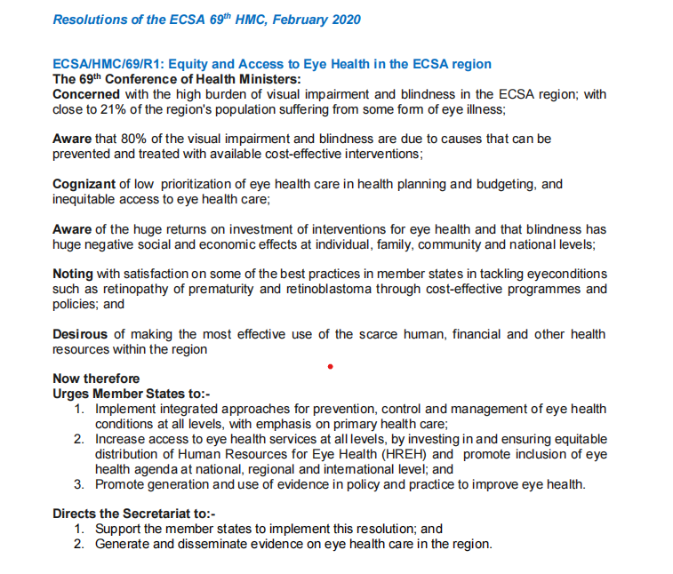

Dr. Urasa reaffirmed ECSA HC’s commitment to advancing eye health in the region through coordinated efforts, innovation and partnership with COECSA and IAPB.

The Committee deliberated on two key issues; The structure of ECSA HC especially the advisory committee and how the expert committee can plug into it and the communication and feedback gaps from ECSA HC to the committee in particular with regards to themes, sub-themes and dates for the subsequent best practice forums and health ministers conference.

***3.3.1 Feedback from 14th BPF and 30th DJCC meeting.***

At the 74th Best Practices Forum (BPF) held in Arusha, Tanzania, the Eye Health Expert Committee was represented by Josiah Anyango and Tesfaye Adera who provided their experiences to the committee. During the forum, two abstracts on eye health, centred around the sub-themes of Technology in Health and Non-Communicable Diseases (NCDs), were submitted and presented. The eye health topics were well-received and they informed the recently passed resolutions.

However, some challenges were noted, particularly in communication. Both the ECSA-HC team and members of the Eye Health Expert Committee faced communication gaps, and limited notification time led to rushed planning for the event.

It was brought to the attention of the committee that the ECSA-HC team is currently working on finalizing the themes for the upcoming 75th Health Ministers Conference, set to take place from February 10-12, 2025, in Lilongwe, Malawi, with details to be announced in due course. <https://ecsahc.org/hmc/>

***3.3.2 Central, Southern and Eastern Africa Human Resources for Eye Health.***

Simon Day, Head of the Africa Region at IAPB, presented an overview of the Human Resource for Eye Health (HReH) strategy for 2014-2018, which laid the foundation for the current strategy. He highlighted key achievements from that period, including the integration of eye health into human resources for health plans across ten countries, the publication of the WHO Eye Care Competency Framework, and a comprehensive mapping of eye health training programs and institutions in the region. The strategy also led to increased engagement between Ministries of Health, training institutions, and eye care providers. However, challenges were noted, particularly related to national level funding commitments.

The presentation was preceded by a presentation by Josiah, the CEO COECSA who introduced the new Central, Southern, and Eastern Africa Human Resources for Eye Health Strategy (2025-2030). He detailed the collaborative development process involving various eye health stakeholders, highlighting that the strategy was informed by the current burden of vision loss and imbalance in the distribution of eye health workers. Josiah explained that this new strategy builds upon the previous HReH strategy (2014-2018), which led to the establishment of National Prevention of Blindness Committees across the region.

He shared the vision, goals, and objectives of the 2025-2030 strategy, emphasizing the importance of regional coordination mechanisms. He noted that an M&E framework is already in place, with the development of a detailed implementation strategy scheduled for completion by February 2025.

***4.0 ECSA HC Opportunities to promote the HReH strategy.***

Dr. Urasa presented the available opportunities within ECSA-HC to strengthen the eye health workforce across Central, Southern, and Eastern Africa, highlighting ECSA-HC’s strategic role in advancing the Human Resources for Eye Health (HREH) Strategy.

She highlighted the role of ECSA HC in promoting the HReH strategy as:

In **policy advocacy**, ECSA HC can work with member states to integrate the HReH strategy into national human resources for health plans (HRH) ensuring eye health becomes a priority.

**Regional coordination**: ECSA HC can facilitate cross border collaboration, standardizing training programs, and enhancing the mobility of eye health workers within the region.

**Knowledge sharing:** Through Communities of Practice (CoP), ECSA HC can create platforms for regional learning and exchange of best practices.

Three key opportunities for engagement within the East, Central, and Southern Africa Health Community (ECSA-HC) were outlined that could advance Human Resources for Eye Health (HREH) initiatives as:

1. **Leverage Regional Networks**: ECSA-HC’s regional networks can be used to amplify the HReH strategy, promoting capacity building initiatives and resource mobilization efforts.
2. **Promote Standardization of Training**: This involves facilitating the adoption of harmonized eye care training curricula across member states to improve the quality and recognition of eye health professionals.
3. **Advocate for Digital Health Innovations**: ECSA-HC can promote the use of digital technologies, such as telemedicine and AI in eye health, expanding access to rural and underserved areas.

Dr. Urasa discussed ECSA-HC's role in advocacy, forging strategic partnerships for resource mobilization, and supporting regional monitoring and evaluation (M&E) frameworks to track progress. She proposed that ECSA-HC could coordinate annual regional reviews to assess milestones, identify challenges, and adapt the strategy as needed to ensure alignment with workforce needs.

The presentation accentuated the importance of ECSA-HC's active involvement in promoting and implementing the HREH strategy as part of a concerted effort to improve eye health access and outcomes across the region.

**4.1 Workshopping on the opportunities to promote the HReH Strategy**

The committee discussed the opportunities around the three key areas: Regional coordination, policy advocacy and knowledge sharing and came up with the following:

**Policy Advocacy**

* *Integration with National Strategies*: Advocate for the integration of the Human Resources for Eye Health (HReH) strategy into national human resources for health strategies (HRH).
* *Data Collection*: Gather data to support the need for additional workshops and resources.
* *Resource Mobilization:* Secure funding for training centres to improve capacity for eye health education and services.

**Regional Coordination**

* ***Cross-border Collaboration***: Identify and establish collaborations with partners and policymakers through ECSA HC.
* MOH through the National Eye Care Coordinators, regulatory authorities e.g AMCOA and office of Permanent Secretaries.
* Collaborative eye health partners.
* Cross border knowledge and service exchange.
* ***Standardization of Training Programs:*** Convene teaching institutions (formal and collegiate systems) to look at the training needs and existing opportunities.
  + ***Standardization of curriculum based on minimum standards.***
* ***Mobility of eye health workers. Commitments by governments through empowerment and equipping of health service delivery points will be a strong motivator for the retention of HReH.***

**Knowledge Sharing**

* *Community of Practice (CoP):* Assess existing CoPs, establish an eye health-focused CoP, and facilitate collaboration with other CoPs.
* *Report Dissemination*: Share a report from the ECSA-HC meeting through the ECSA communications team.
* *Strategy Communication:* Introduce and disseminate the HReH strategy at the next Best Practices Forum (BPF) to raise awareness and promote adoption.
* *Evidence Generation:* Leverage the ECSA-HC knowledge team for evidence generation to support strategy implementation and policy advocacy.

**4.2 The recommendation from the committee**

The ECSA HC Eye Health Expert Committee directs the secretariat to ***Facilitate human capacity development for eye health.***

***4.3 Way Forward and next steps***

* **Maximizing ECSA-HC Opportunities**: The Eye Health Expert Committee will focus on leveraging the opportunities provided by ECSA-HC to strengthen eye health initiatives.
* **Engagement with New Leadership**: Following the appointment of a new Director General, the committee will designate a delegate to pay a courtesy call to the office, introduce the committee, and discuss potential collaboration.
* **Establishing Communication Channels**: Develop clear communication pathways between ECSA-HC and the expert group, including adding the expert committee secretariat to the ECSA-HC mailing list.
* **Resolution Mapping for Strategic Alignment**: Conduct a mapping exercise of ECSA-HC resolutions to identify those relevant to eye health and determine where the HReH strategy can be anchored.
* **HReH Strategy Dissemination**: Plan for the dissemination of the HReH strategy at the upcoming Best Practices Forum.
* **Collaboration on 75th Health Ministers Conference (HMC) Themes**: The secretariat will work closely with the Health Systems and Cluster Manager to align communication on the themes and sub-themes for the 75th HMC.

# **Annexes**

**Annex 1: Program for the ECSA-HC Eye Health Expert Committee meeting**

**Dusit Princess Hotel Residences Nairobi**

**29 October 2024**

|  |  |  |
| --- | --- | --- |
| **Time** | **Agenda item** | **Lead** |
| 0830 | * Registration |  |
| 0900 | Welcome and introduction | Committee Chair |
| 0915 | ECSA HC Update:   * 14th Best Practices Forum (BPF) * 73rd Health Ministers’ Conference | ECSA HC |
| 0945 | Unpacking the Central, Southern and Eastern Africa Human Resources for Eye Health Strategy (2025-2030) | IAPB&COECSA |
| **1030** | **Break** |  |
| 1050 | ECSA HC Opportunities to promote the HReH strategy | ECSA HC |
| **1200** | **Lunch** |  |
| 1300 | ECSA HC Expert Committee on Eye Health response   * Workshopping ways to leverage ECSA HC opportunities to promote the HReH Strategy | IAPB&COECSA |
| **1430** | **Break** |  |
| 1445 | ECSA HC Expert Committee on Eye Health response…   * Workshopping ways to leverage ECSA HC opportunities to promote the HReH Strategy | IAPB&COECSA |
| 1545 | Summary and next steps | Committee Chair |
| 1600 | Meeting Close |  |